TECHNICAL SPECIFICATION:
PASSIVE-ACTIVE HYBRID VIBRATION SUPPRESSION SYSTEM
Document ID: TS-2026-VIB-042
Date: Saturday, July 11, 2026
Project: Aquila UAV Autonomous Sensor Pod Infrastructure
Subsystem: Optical Bench Stabilization Matrix
Lead Systems Engineer: Dr. White / Sovereign Physical AI Division
Status: Approved for Production Print & Physical Integration
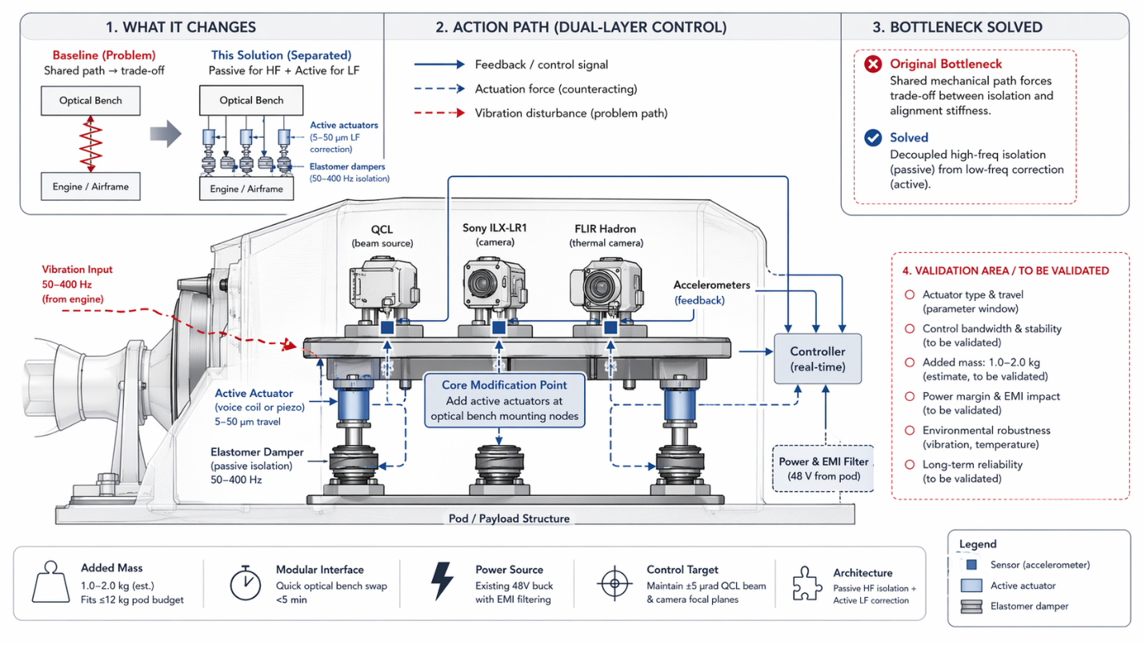
1. Executive Summary & Design Intent
Airborne mid-infrared (mid-IR) spectroscopy and high-resolution optical imaging within the Aquila sensor pod are fundamentally constrained by engine-induced structural dynamics. High-frequency structural shaking and low-frequency flight displacements degrade the optical path alignment of the quantum cascade laser (QCL), introduce beam jitter, and blur the focal planes of the accompanying sensor array (Sony ILX-LR1 and FLIR Hadron).
This document defines the engineering framework for a Passive-Active Hybrid Vibration Suppression System. By replacing the traditional single-layer trade-off with a frequency-separated, multi-tiered isolation and correction matrix, this design ensures a laboratory-grade optical environment inside a high-vibration drone hull. The architecture utilizes TRIZ Condition Separation (Principle #1: Segmentation and Principle #40: Composite Materials) to decouple high-frequency attenuation from real-time low-frequency micro-displacement correction.
2. TRIZ Contradiction Analysis & Condition Separation
2.1 The Systemic Physical Contradiction
A fundamental conflict exists when mounting sensitive optical equipment inside an airborne vehicle:
- To maximize high-frequency vibration isolation, the mounting interface must be soft and compliant (low stiffness $k$), allowing the dampers to absorb energy.
- To preserve optical alignment and pointing accuracy, the mounting interface must be highly rigid (high stiffness $k$) to prevent structural sag, drift, and dynamic displacement during flight maneuvers.
Traditional solutions enforce a compromise, resulting in either a heavy gyrostabilized gimbal platform or degraded spectral sensitivity due to optical jitter.
┌─────────────────────────────────────────┐
│ PHYSICAL CONTRADICTION: MOUNT STIFFNESS │
└────────────────────┬────────────────────┘
│
┌──────────────────────┴──────────────────────┐
▼ ▼
[ Soft Dampers (Low k) ] [ Rigid Standoffs (High k) ]
• High-frequency isolation active • Preserves alignment stability
❌ Fails: Mechanical sag during turns ❌ Fails: Transmits engine noise
2.2 Inventive Solution Principles
Applying TRIZ Condition Separation resolves this contradiction by partitioning system response based on the frequency and amplitude of incoming disturbances:
- Principle #1 (Segmentation): The structural load path is physically separated into two distinct, independent functional layers in series: a passive elastomeric isolation boundary and an active electromechanical correction interface.
- Principle #15 (Dynamics): The system adapts dynamically in real time, moving from a compliant state to an actively rigid state depending on telemetry inputs.
- Principle #40 (Composite Materials / Condition Separation): High-frequency engine vibrations ($50\text{--}400\text{ Hz}$) are handled passively by visco-elastic damping composites, while low-frequency micro-displacements ($5\text{--}50\text{ }\mu\text{m}$) are actively counteracted by high-bandwidth piezoelectric or voice-coil actuators.
3. Structural & Mechanical Layout
The structural stabilization spine splits the physical disturbance path into two distinct control layers, neutralizing environmental inputs before they reach the rigid optical bench.
[ENGINE / AIRFRAME VIBRATION SOURCE] (50–400 Hz Engine Rotation)
│
▼
[1. ELASTOMER DAMPERS] <── Passive Isolation Layer (Copterlab Mounts)
│
▼ (Residual 5–50 µm Low-Frequency Displacement)
[2. ACTIVE ACTUATORS] <── Closed-Loop Voice Coil / Piezo-Elements
│
▼ (Controlled to ±5 µrad Target Window)
[RIGID OPTICAL BENCH] ──► Ingests: QCL Beam Source / Sony ILX-LR1 / FLIR Boresight
3.1 Passive Dampening Layer
The primary interface matches the existing Copterlab elastomer damper mounts ($STR-POD-001$). These mounts are engineered with a specific visco-elastic compound tuned to act as a mechanical low-pass filter:
- High-Frequency Transmissibility: For environmental noise in the $50\text{--}400\text{ Hz}$ range, the dampers absorb kinetic energy, achieving an attenuation factor of $>30\text{ dB}$ across the target band.
- Static Load Path: The dampers sustain the static mass of the isolated core without experiencing compression set under continuous flight loads.
3.2 Active Displacement Correction Layer
Positioned at the mounting standoffs of the rigid internal optical bench are four co-axial active actuators:
- Actuator Hardware: Compact, high-precision electromagnetic voice-coil motors or multilayer ceramic piezoelectric actuators.
- Operating Range: Optimally sized for a travel window of $5\text{--}50\text{ }\mu\text{m}$, delivering fast reaction forces along the primary optical alignment axes.
- Mounting Interface: Utilizes a custom, tool-less quick-disconnect buckle assembly that secures the active module to the bench structure, guaranteeing a swap runtime of under 5 minutes for rapid field servicing.
4. Electro-Mechanical Control Loop
The active suppression system operates as a high-bandwidth, closed-loop feedback network powered by the board-level controller.
┌───────────────────────────────────────────────────────────────┐
│ │
│ ┌───────────────┐ Telemetry ┌────────────┐ │
└──►│ Accelerometer ├──────────────────►│ Controller │ │
└───────▲───────┘ └─────┬──────┘ │
│ │ │
│ Physical Vibration │ Control Signal │
│ ▼ │
┌───────┴───────┐ Actuation ┌────────────┐ │
│ Optical Bench │◄──────────────────┤ Actuator │ │
└───────────────┘ └────────────┘ │
│
└───────────────────────────────────────────────────────────────┘
4.1 Sensor Feedback Array
Ultra-sensitive, low-noise tri-axial MEMS accelerometers are hard-mounted directly to the chassis nodes of the core optical payloads:
- Hamamatsu L12004 QCL (Mid-IR Beam Source)
- Sony ILX-LR1 (High-Resolution Focal Plane)
- FLIR Hadron (Thermal Imaging Boresight)
These sensors continuously sample translational and angular accelerations, feeding raw telemetry streams to the real-time processor over a dedicated high-speed CAN Bus line.
4.2 Controller Logic & Power Shunt
The central microcontroller (integrated into the Jetson AGX Orin carrier board interface) runs a real-time digital signal processing (DSP) loop:
- Algorithm: Executes a predictive counter-phase force vector calculation based on dynamic state estimators.
- Control Bandwidth: Runs at a minimum sampling rate of $2\text{ kHz}$ to prevent delay-induced phase lag.
- Power Distribution: Powered directly by the primary $48\text{ V}$ step-down buck converter. Dual-stage EMI ferrite cores are integrated on the power input lines to isolate switching noise and prevent electromagnetic feedback from corrupting the sensitive analog sensor lines.
5. Physical Budgets & Operational Boundaries
To ensure seamless integration with the existing Aquila UAV platform, the hybrid isolation system complies with the following strict physical and electrical limits:
Technical Parameter | Target Design Value | Validation Boundary & Conditions
Active Actuator Mass | $1.0\text{--}2.0\text{ kg}$ | Must fit within the maximum $\leq 12\text{ kg}$ total sensor pod weight limit.
System Power Draw | $\leq 25\text{ W}$ nominal / $60\text{ W}$ peak | Powered directly from the $48\text{ V}$ DC bus step-down rail.
Target Alignment Window | $\pm 5\text{ }\mu\text{rad}$ | Maintained continuously during high-dynamic flight maneuvers.
Residual Bench Vibration | $\leq 5\text{ }\mu\text{m}$ | Measured at the optical bench nodes across the $50\text{--}400\text{ Hz}$ band.
System Interface Swap Time | $< 5\text{ minutes}$ | Achieved using tool-less snap-fit locking buckles.
6. Verification & Validation Protocol (To Be Confirmed)
Five primary engineering uncertainties must be systematically validated inside the simulation loop and physical test rigs before full field deployment:
- Actuator Stroke Optimization: Map the precise control boundaries of the voice-coil/piezoelectric travel to ensure the actuator rods do not bottom out or clip their hard-stops during heavy airframe buffeting.
- Control Loop Stability: Program and verify the real-time PID/H-infinity algorithms on the microcontroller to prevent self-induced harmonic resonance loop oscillations across the $50\text{--}400\text{ Hz}$ input band.
- Galvanic Corrosion Isolation: Verify material properties at the interface where the silver-coated copper or nickel-graphite conductive shielding gaskets compress ($2\text{--}5\text{ mm}$ fit) against the raw carbon fiber housing to prevent galvanic oxidation under humid field conditions.
- Long-Term Contact Resistance Drift: Test the EMI shielding seams to ensure contact resistance remains $\leq 0.1\text{ }\Omega/\text{sq}$ along the housing lid, connector pass-throughs, and vent-gap perimeters to block $10.5\text{ GHz}$ slot-antenna noise.
- Environmental Robustness: Evaluate the thermal dissipation performance of the active actuator coils when sealed inside the pod enclosure alongside the heat rejection paths of the core sensors.

